
Jesus and Mary College
Department of Economics
Overview 2022-23

Academic year 2022-23 has been another fruitful year for the Department of Economics. An array of activities kept the year vibrant and exuberant. The Report portrays the wide spectrum of academic and co-curricular activities that happened throughout the year.

19 July 2022

Council Elections
The council elections of the Department of Economics for the year 2022-2023 took place on 19th July 2022. Gemma Maria Tony emerged as the President and Anandita Esther Chaudhary as the Vice President of the Department of Economics.
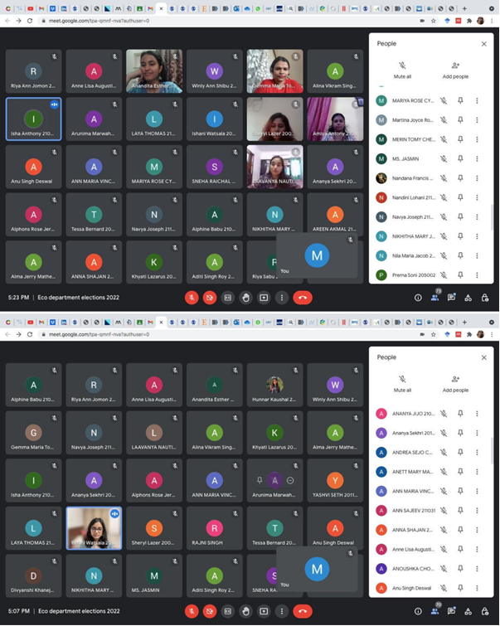

29 August 2022

Engaging with the Alumnae - Session 1

Alumnae Speaker: Ms. Srishti Pal, Batch of 2020
Ms. Srishti Pal conducted a productive Alumni connective session which enabled the students to understand the procedure to get admission abroad. The session was attended by 50 participants including the teachers.

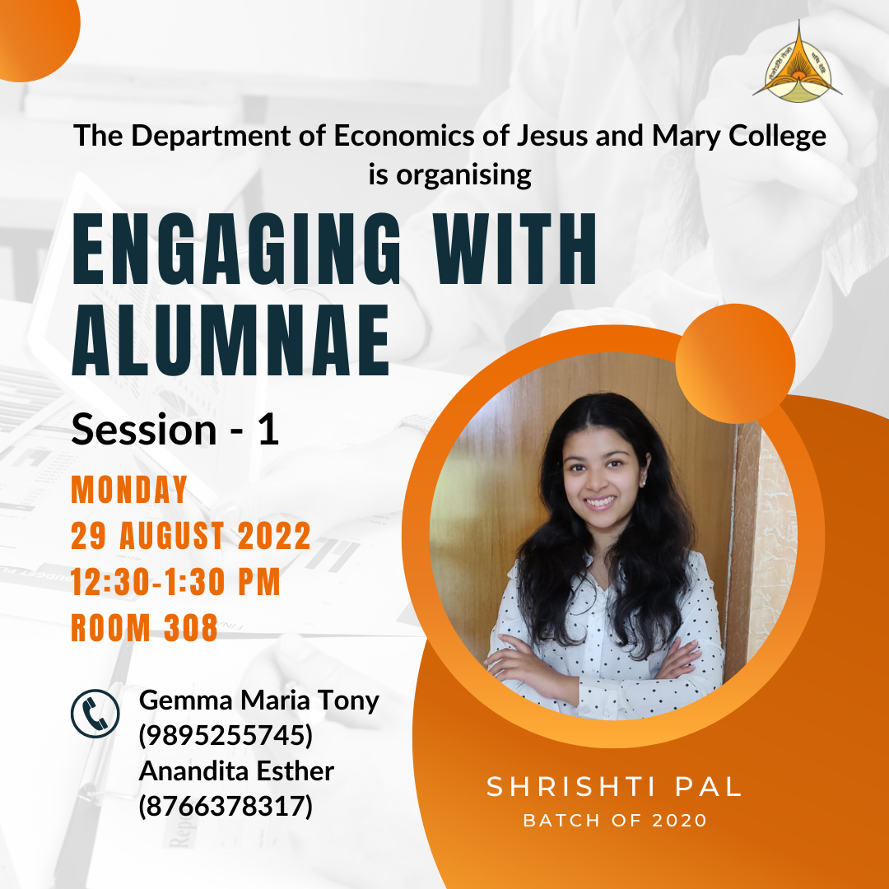

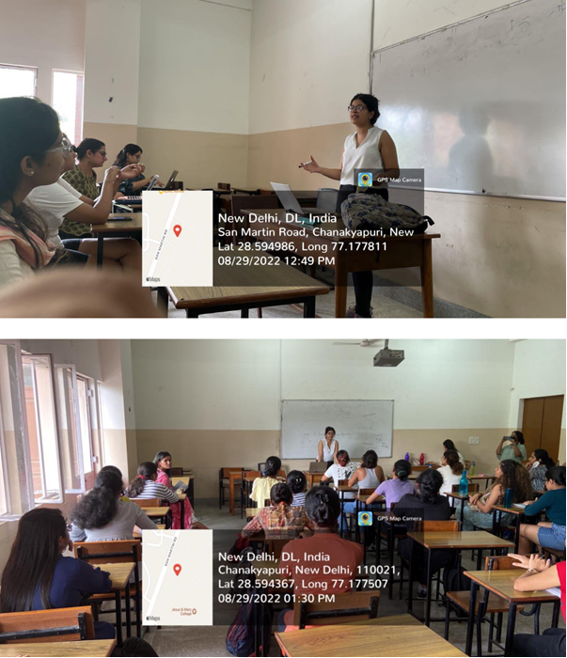

7 September 2022

Speaker Session-1

Speaker- Prof. Mona Khare

Designation- Professor & Head, Department of Educational Finance, at Centre for Policy Research in Higher Education, National Institute of Educational Planning and Administration, New Delhi

Topic: Graduate Employability - A Continued Challenge
Prof. Mona Khare led an impactful session on Graduate Employability: A continue challenge. The session was attended by students of both, The Economics Honors course and BA programme course.
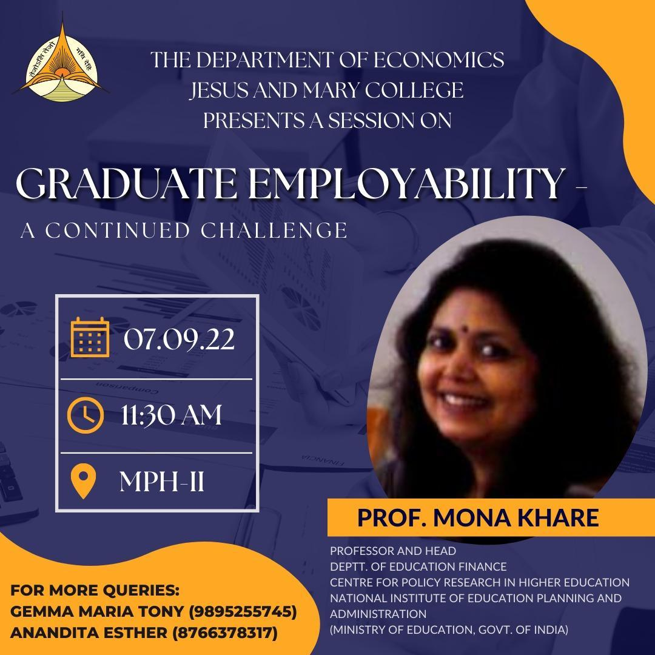

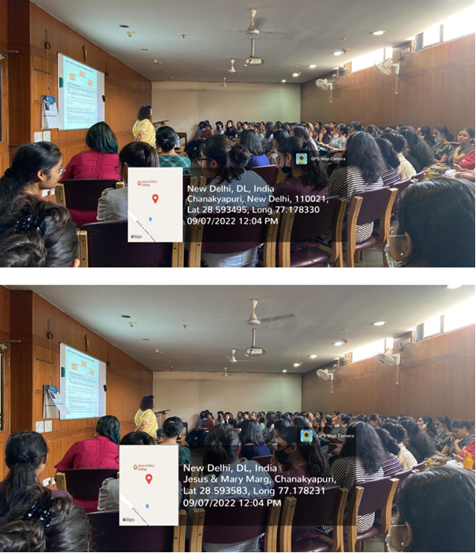

27 September 2022

Speaker Session-2

Speaker- Dr. Srishty Kasana

Designation- Assistant professor at PGDAV College, University of Delhi and a Research Scholar at the Department of Finance and Business Economics, University of Delhi

Topic: Impact of Climate Change On Uttar Pradesh's Agriculture
Dr. Kasana led an insightful session which was based on extensive research and focused on climatic change and the long-term shifts in temperature and weather patterns.
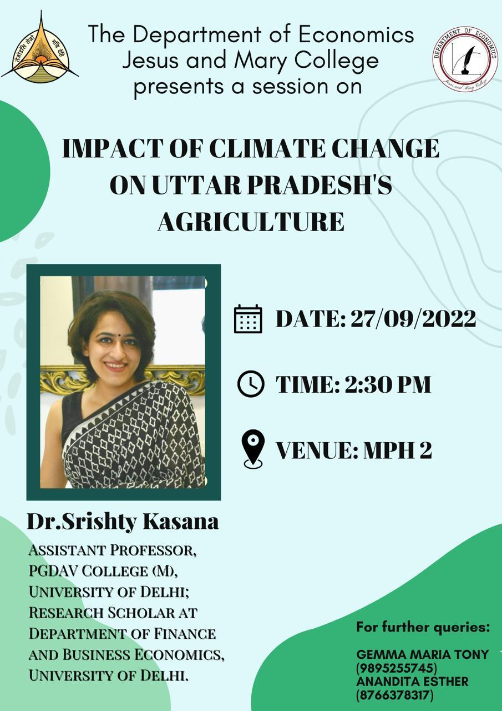

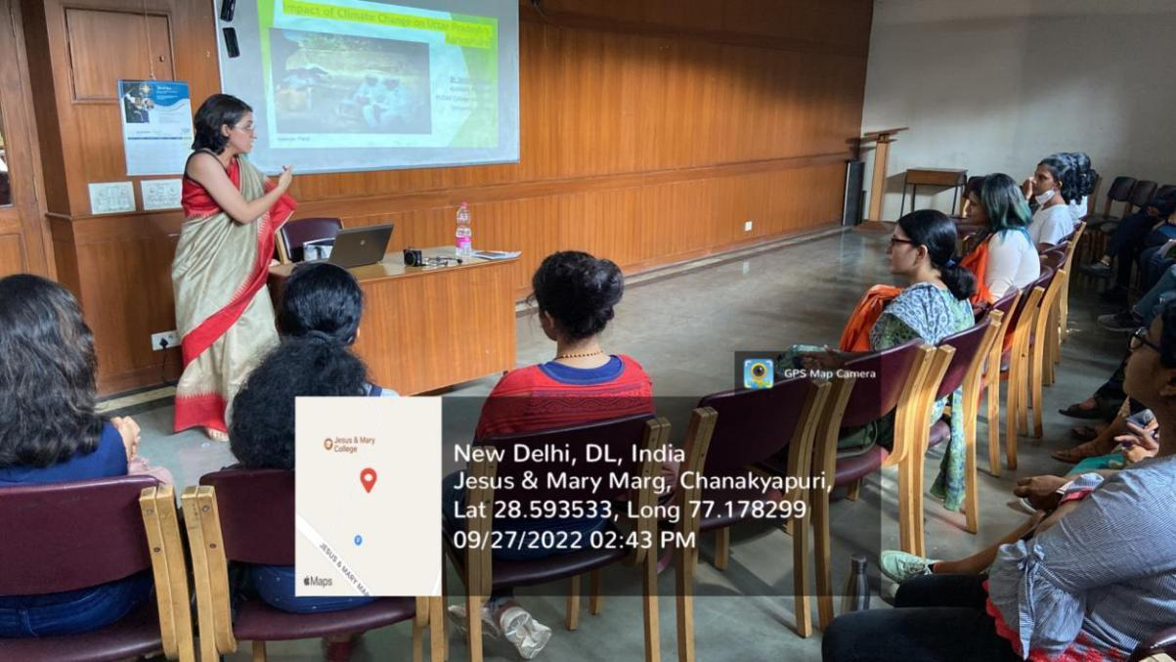
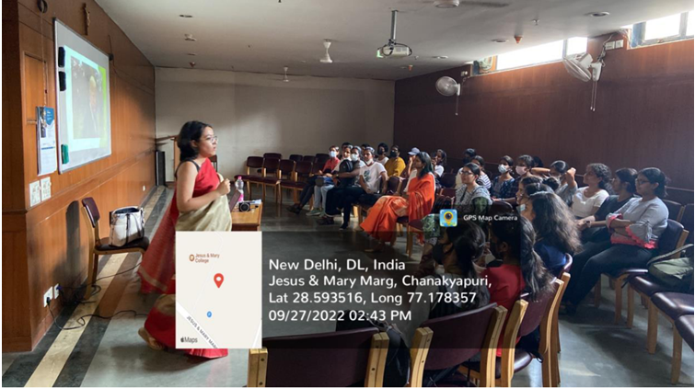
TOWARDS THE END OF SESSION, THE SPEAKER CLARIFIED THE DOUBTS OF THE STUDENTS.

30 September 2022

Webinar in collaboration with MDAE, Mumbai

Speaker- Dr. Amlesh Kanekar

Designation- Director of Academics at Meghnad Desai Academy of Economics, Mumbai with a 30+ years’ experience in Information Technology

Topic: Telling a Data Story using a visualization tool (power BI)
Mr. Amlesh Kanekar, director of Academics at MDAE, led an effective session where he discussed about the importance of storytelling and how using a powerful visualization tool (Power BI) makes it more effective.
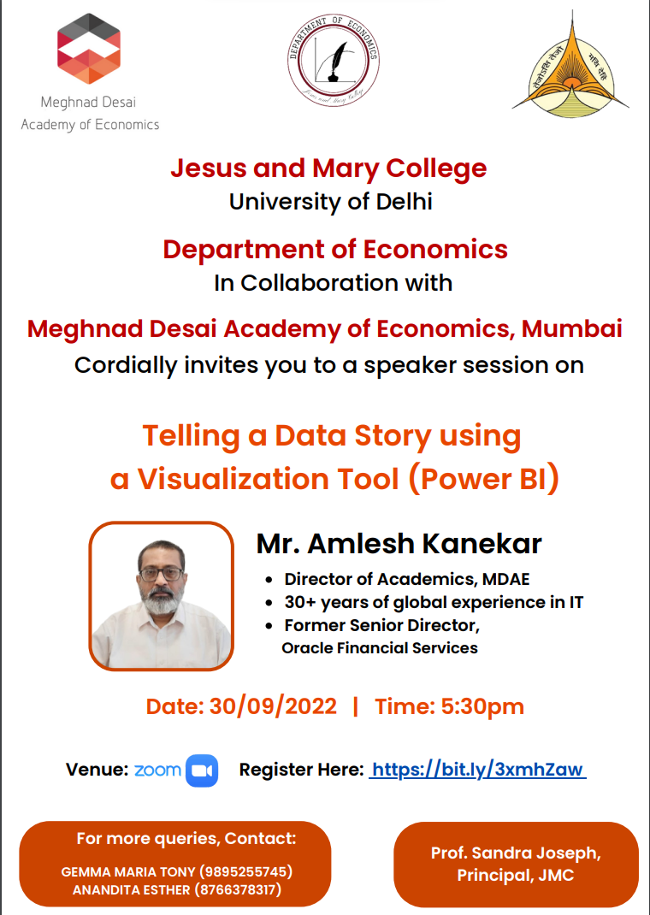

Towards the end of the session, the speaker resolved the doubts that the students had and made the session more knowledgeable one.

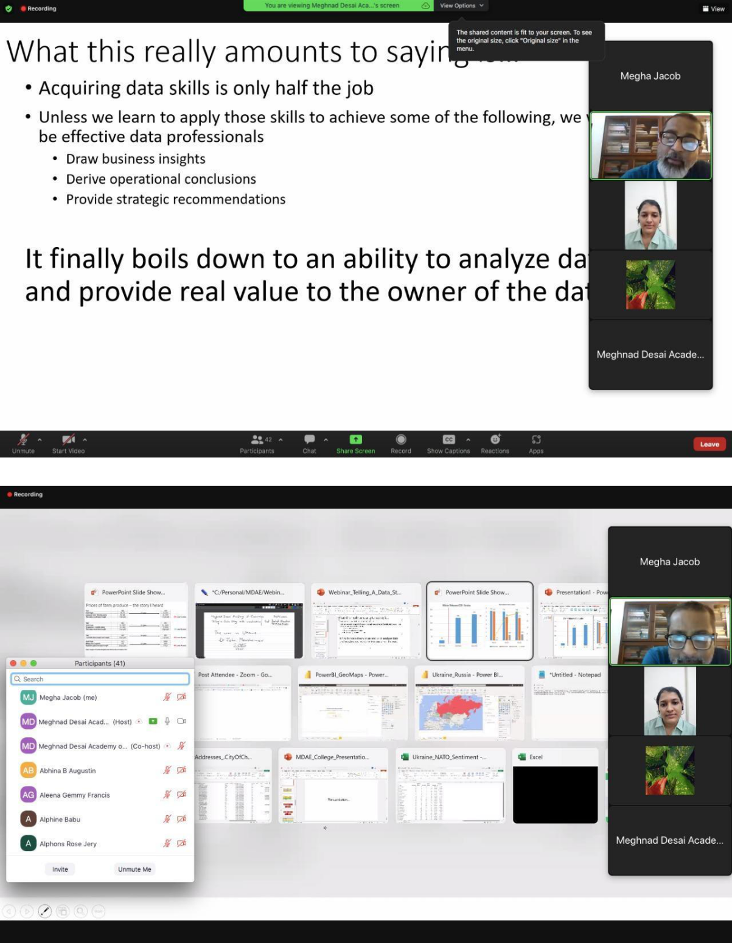

30 October 2022- 5 November 2022

Online Workshop on Research Methodology in Social Sciences
The Department of Economics hosted a six-day workshop on ‘Research Methodology in Social Sciences’ to acquaint learners with the various techniques and tools used in social science research.

Speakers-

Dr. Indranil Chowdhury

Associate Professor in the Department of Economics PGDAV College

Title of PhD dissertation: “Monetary Policy and Inflation in India since 2000”. With Monetary Economics and Macroeconomics as areas of interest

Dr. Chandan Jain

Senior Evaluation Specialist at 3ie

Supports 3ie’s livelihoods programs, including the National Rural Livelihoods Mission impact evaluation, evaluation of the HMF’s Collective Impact Initiative and the Women’s Social and Economic Inclusion and Empowerment in India Evidence Programme

Dr. Krishna Ram

School of Undergraduate Studies -Economics, Ambedkar University, Delhi

Areas of research: Poverty, Inequality, Health, Nutrition, Labor, and Applied Econometrics. With publications in reputed journals like the Contemporary Voice of Dalits, Economic and Political Weekly, the Social Scientist and many more

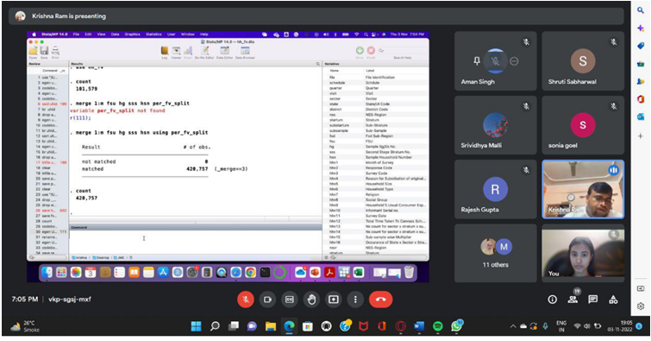

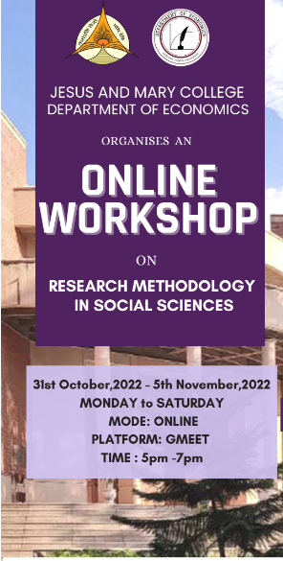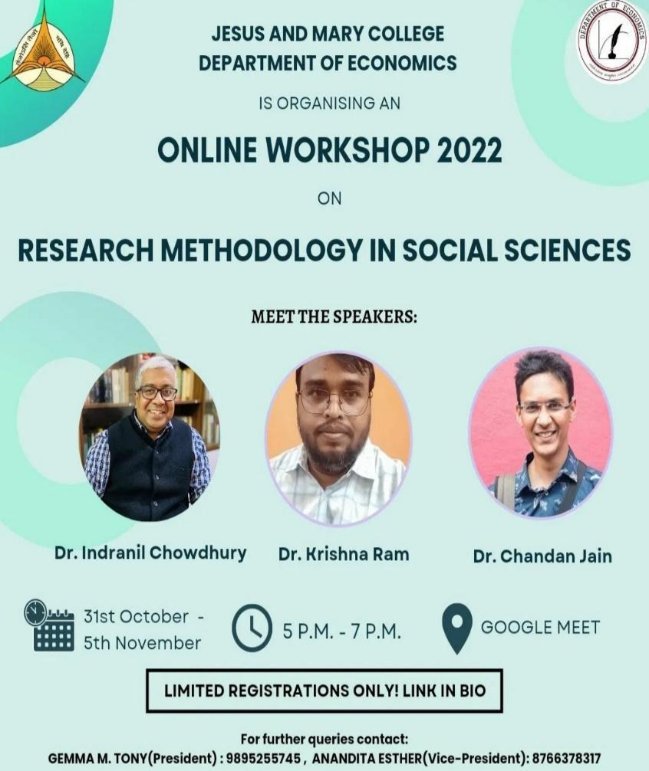
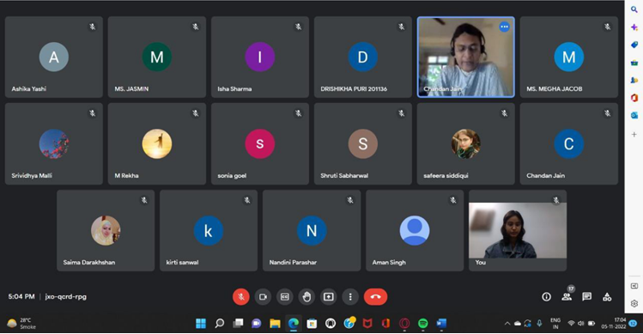

Alumna Talk: Ms. Alisha Gragya (December)

Date: December 7, 2022
Time: 6:30-8 pm
Platform: Google Meet
TOTAL ATTENDEES: 65

Chanakya, The Economics Cell of Jesus and Mary College, conducted an “Alumna Talk” with Ms. Alisha Gragya, batch of 2022, on December 7, 2022, from 6:30-8pm. The event was held on Google Meet and was actively attended by 65 attendees.
The event commenced with a welcome address by Sur Gupta and Anshika. Post the welcome address and introduction, Ms. Alisha Gragya steered the conversation in such a manner that gave the attendees a bird-eye view of life after college. Ms. Gragya began by describing some top colleges in India such as IIM Ahmedabad, IIM Bangalore and IIM Calcutta, which exponentially brighten career prospects. Ms. Gragya shared her valuable experience for cracking the Common Admission Test (CAT) by briefly discussing how to ace its various sub sections such as Verbal Ability and Reading Comprehension, Data Interpretation and Logical Reasoning, General Knowledge and Decision Making among others. The speaker then delved into enlightening the attendees about the selection process for those considering to pursue Master of Business Administration (MBA), while emphasizing the significance of personal interviews along with some guidelines for better preparation. By sharing her own experiences
at IIM Kozhikode, Ms. Gragya offered a real-life painting of life as a Post Graduate Programme
student. Subsequently, the floor was opened for questions from the attendees. The event ended with a vote of thanks by Sur Gupta and Chanakya’s President, Nandini Sunil.
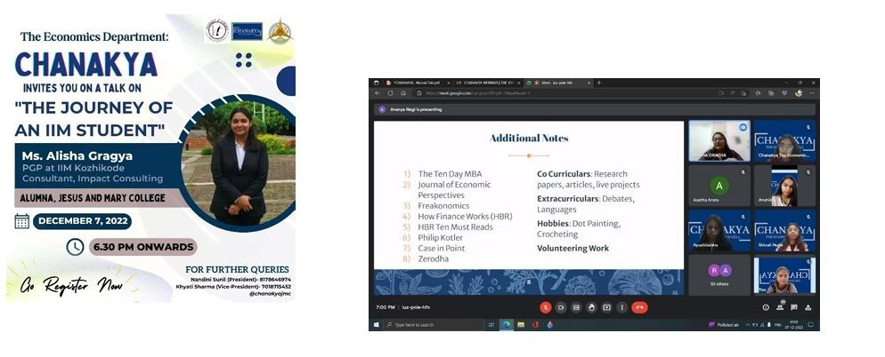

Group discussion: Budget (February)
Date: February, 15, 2023
Time: 3-4pm
Place: College Premises
TOTAL ATTENDEES: 13
Chanakya, The Economics Cell of JMC successfully organized a group discussion on the Budget of 2023 on 15th February for its members within the college premises. The discussion commenced with the President of the society giving us a brief explanation about the budget and putting forward her opinions, giving us a few interesting facts, followed by the other members taking the discussion forward by putting forth their stance on this year's Budget. The discussion revolved around several key points, one of them being capital expenditure as it has seen a significant amount of money allocation which most of the members touched upon. Another recurrent topic was the new tax regime which was discussed in detail mentioning its merits as well as demerits. One important point that was brought up was the difference between money spent on defense vs. money spent on healthcare, defense having had a higher expenditure jump than healthcare but it isn’t the only point that lacked emphasis in this year's budget, unemployment was another point that was brought up by many members. During the discussion, concerns were raised about inadequate emphasis on job creation. A few mentioned carbon taxation which is important for the country and would be extremely beneficial for the environment. Some even added that this budget focused on capitalizing on youth power and digitalization of education sectors etc. We were also briefly joined by a faculty member of the Economics Department, Ms. Shruti Sabharwal, who enriched the discussion with her insightful information on the budget. She illuminated how this year’s budget is more growth-oriented and also talked about the tax regimes and its impact on the working class and businesses. This discussion covered a wide range of topics including the potential impact of the budget on various sections of the society, the advantages and limitations, and the need of greater investment in areas like environment and healthcare. The overarching takeaway of the discussion was that the budget is just a structure that needs to be implemented. The discussion was conducted in such a way that members who did not have economics in their curriculum could get a bird-eye view of the Budget and even voice their opinions. Overall, it was a successful group discussion as it helped the members speak up and also gain insight on each other’s opinions which definitely added up to a good experience. The discussion came to end with the vote of thanks being delivered by the President, Nandini Sunil.
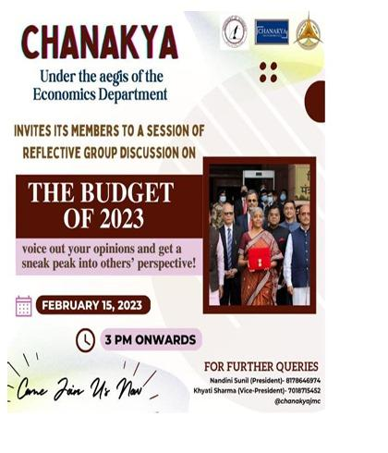
Short film screening followed by a Group Discussion (February):
Date: February 25, 2023
Time: 7:15 - 8:30 pm
Platform: Google Meet
Visual media has the power to elicit a wide range of emotions in viewers and spark meaningful conversations about a variety of subjects. To tap on this potential, Chanakya, the Economics Cell of Jesus and Mary College conducted a virtual Short Film Screening followed by a contemplative Group Discussion on February 25, 2023. Intertwining movies and economics was an enticing proposition since cinema performs a cognitive function that increases the amount of information students acquire. The session commenced with an introduction by the host for the event, Tanya Khurana, about the importance of cinema and the role of central banks in the economy. The short film “FED HEAD” was screened for the participants where Rob Rafaelson, the Federal Reserve Chairman, awakes with a sudden loss of memory only moments before a big press conference. His children, maid and intern must explain the Fed to him using the only thing handy: the children’s toys. The film cleverly depicted the importance as well as the role of the Federal Reserve through quirky references and metaphors.
The film was followed by a short quiz about the purpose, functioning, and policies undertaken which were answered enthusiastically by the participants. A general group discussion on the federal reserve's role and the policies undertaken was deliberated upon. The question: “Are the constant interest rate hikes by the US FED to reign in inflation, extreme or necessary?” was discussed in detail. There was discussion about the current economic situation and the impact of these economic policies. Many students shared their viewpoints and talked about how policies and actions can impact people on a personal level as well. The faculty members, Ms. Ruchi Bhalla and Ms. Megha Jacob, answered queries and shared their insights which exponentially boosted the enriching caliber of the discussion. The session ended with a vote of thanks by Tanya. The event definitely helped to promote a deeper understanding of central banks and increase the long-term retention of the students who took part in the event.
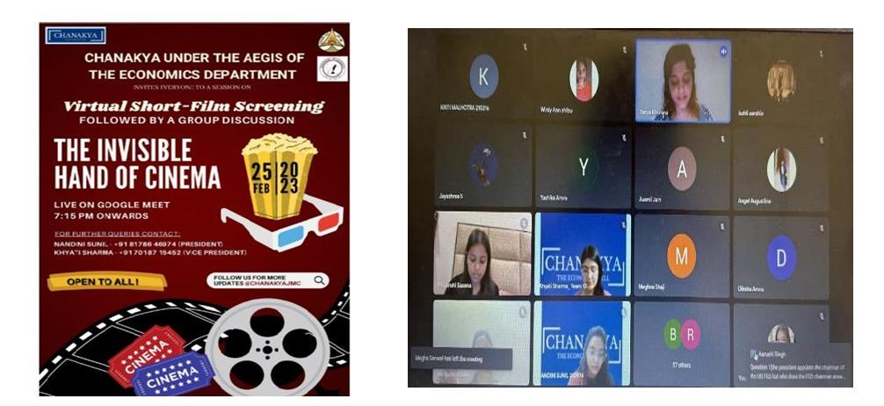

25 February 2023

Speaker Session 3

Speaker: Dr. Apoorva Gupta

Designation: Assistant Professor, Department of Economics, Hansraj College

Paper Title: Exploring the linkage between Education and Financial Autonomy of the Women Working in Urban Informal Sector in India

Dr. Apoorva Gupta, an assistant professor at Hansraj College, DU presented her paper on “Exploring the linkage between Education and Financial Autonomy of the Women working in Urban Informal Sector “to over 40 participants.
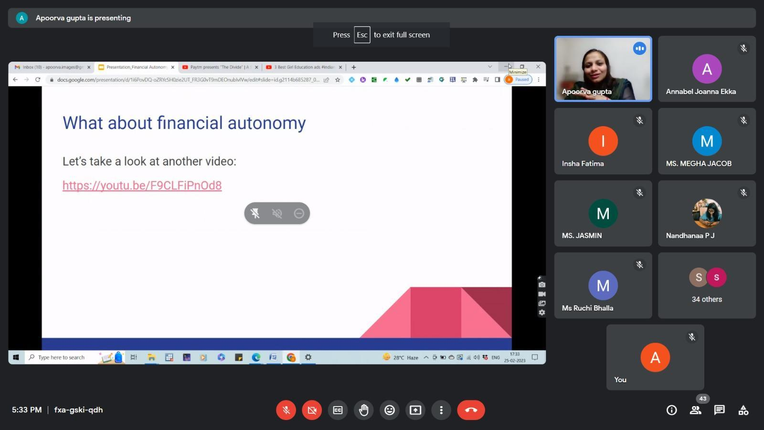

15 March 2023

Engaging with the Alumnae - Session 2

Alumnae Speaker: Ms. Mehar Batra Sindhu
Ms. Mehar Batra Singh, an alumnus of Jesus and Mary College and a well-known Career Specialist, led an insightful session on pursuing an MBA abroad. At the end of session Ms. Batra answered the questions of students present.

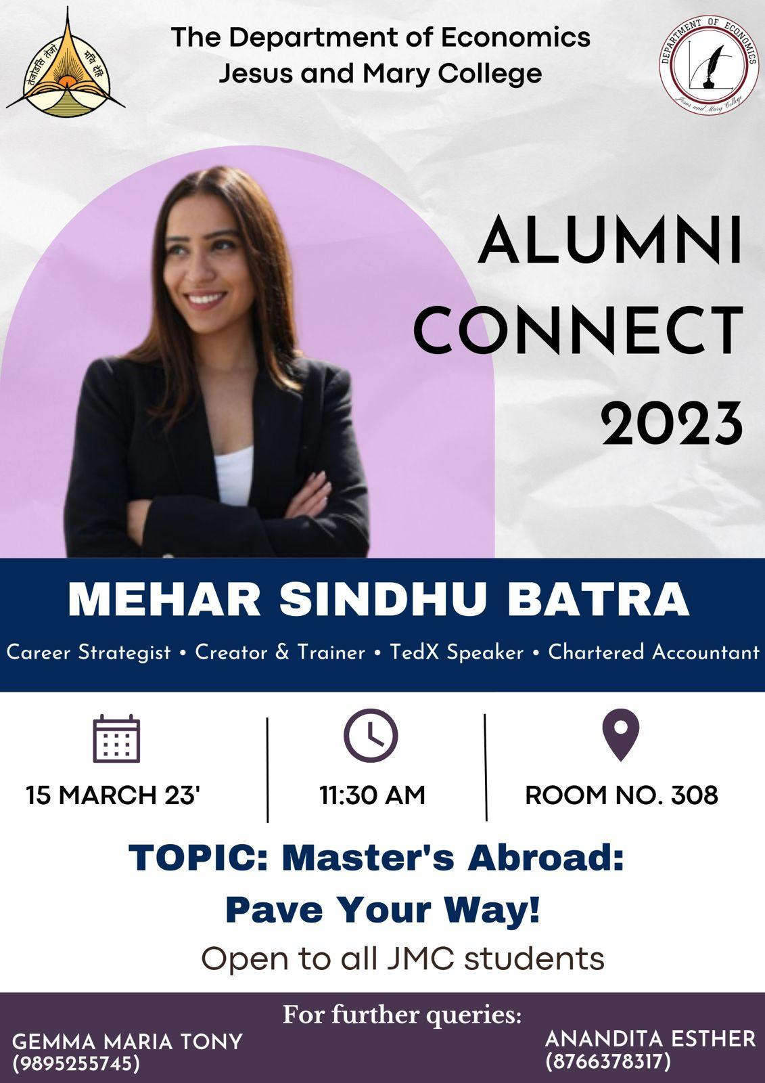
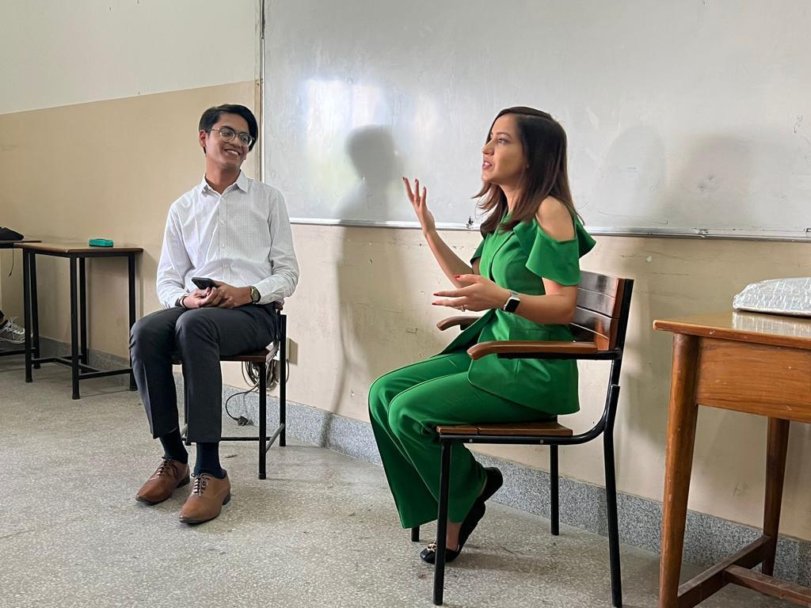

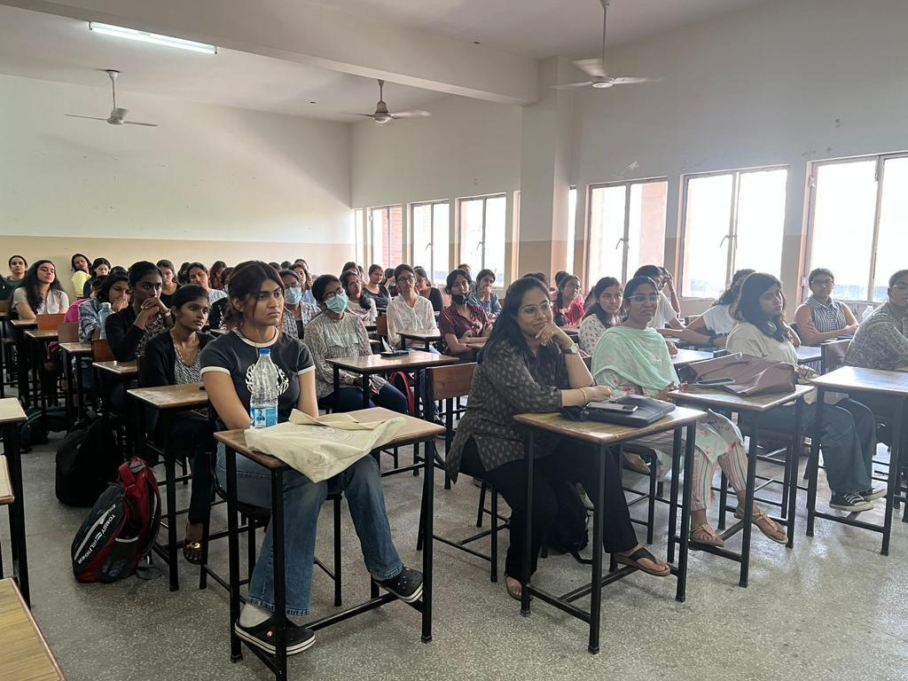

28 March 2023

Ecovantage 2023

Events:

Inaugural Talk

Research Symposium

Puzzle Pint in collaboration with The Puzzle Society

Protagoras-the Debate Competition in Collaboration with Contrarian

Strat Wars in collaboration with IGTS

Stock Talk in collaboration with Chanakya

Xavion in collaboration with Digilit

Open Mic Event
The Department of Economics hosted its Annual Economics Department fest: ECOVANTAGE 2023 with great fervor and exhilaration. The event was inaugurated by a prominent Economics professor, Prof. Ashwini Deshpande and the Principal Prof. Sandra Joseph. This was followed by plethora of events encompassing intellectual activities and an open mic and flashmob as a part of cultural program.
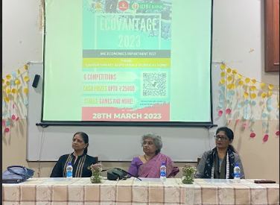

28 March 2023

Ecovantage 2023

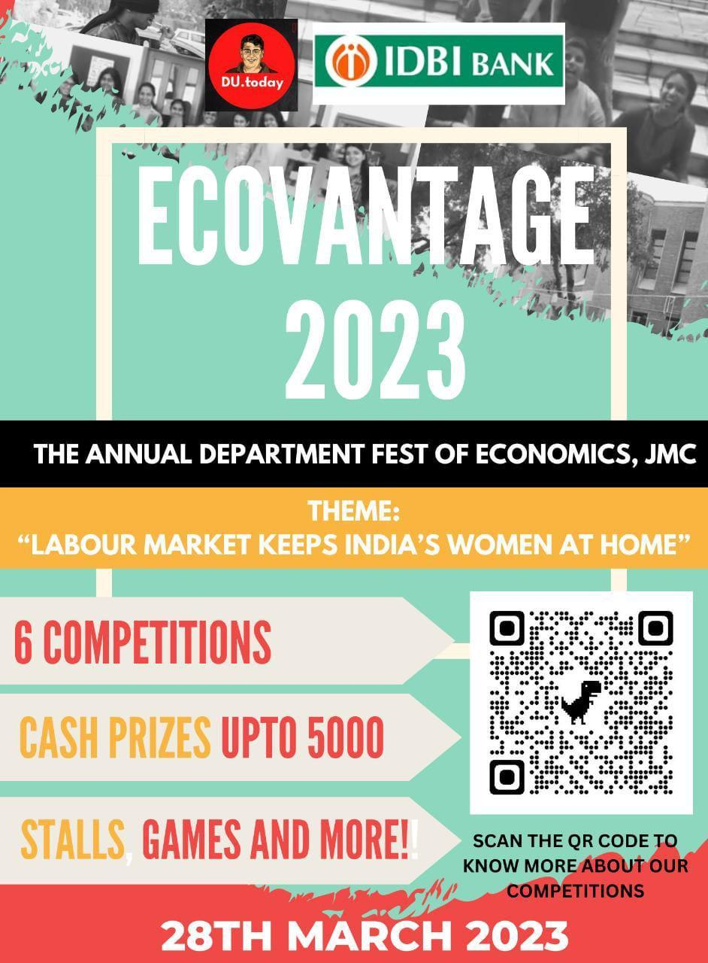

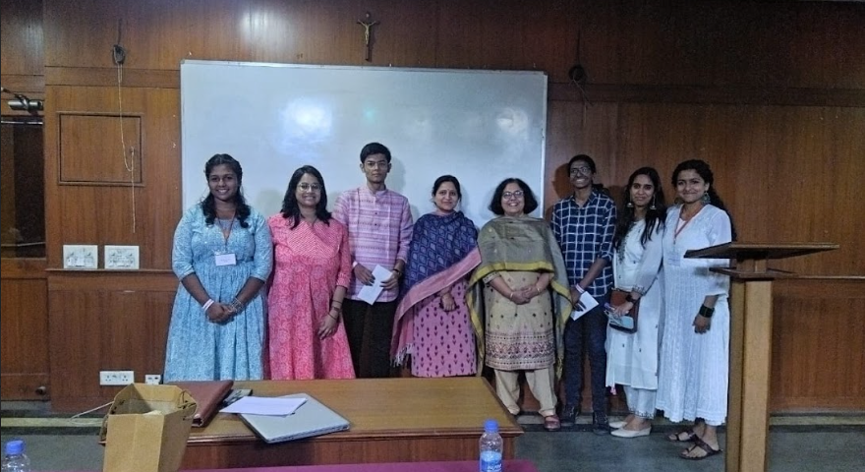
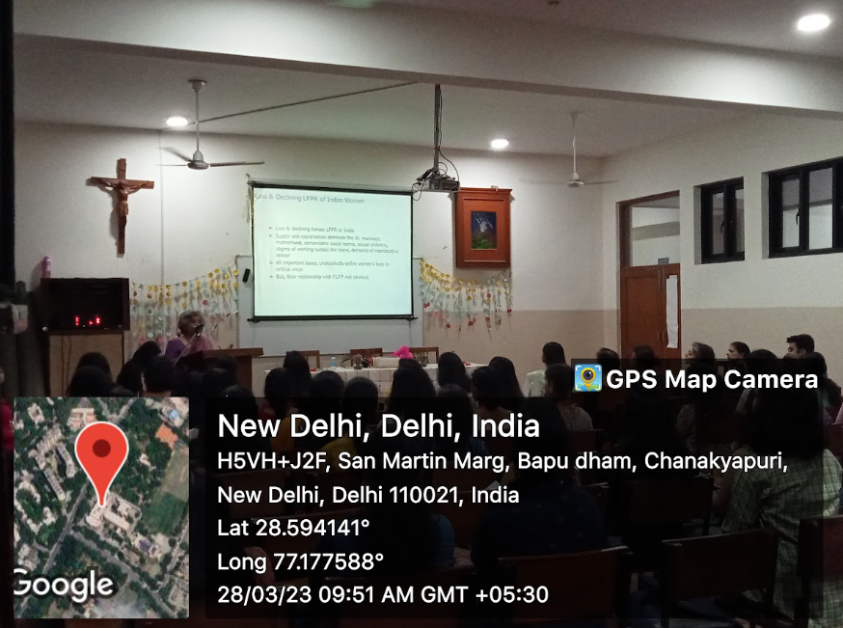
The success of all the events is an absolute consequence of hard work, perseverance and determination exhibited by every member of the team putting in relentless efforts with gusto.

Ecovantage 2023- Stock Talk
DATE: 28 MARCH 2023
TIME: 11.30 pm- 2.30 pm
No. Of Attendees : 85 participants , 20 team member
As a part of Ecovantage, the annual fest of Department of Economics, Chanakya;the Economics Cell organized the Stock Talk competition which was open to all the undergraduate students from across the colleges in Delhi. The participation was allowed to individuals and teams of 2. An overwhelming response was received by students as they registered in large numbers. A Preliminary Round was held on 26 March 2023 . An online quiz was conducted having questions related to the Stock Market where participants were given encrypted PDFs along with the hints. The password for each pdf was the correct answer to the question after which the teams qualified to the next round.. There were a total of 10 rounds at the end of which top scoring teams were shortlisted for the competition.
The Stock Talk Competition was held on 28 march 2023 in 2 Rounds at the college campus. For Round 1, the participants were given 2 commodities, 3 stocks,2 NFTs, 2 Digital assets to invest in with a principal amount of Rs 40 lakhs. News were also displayed on the screen for participants to make their decision to invest. As a surprise element, participants were given an option to take chits which could be a risk or reward in the form of profit or losses. A total time of 25 minutes was to fill in their portfolio sheet. Only the teams that made a profit in Round 1 qualified to Round 2. After checking of the response sheet by the core team, 15 teams were qualified to round 2. In the second round, their profits were added to their principal amount. Then once again, they had a chance to invest in the shares after critically analyzing the market dynamics. At the end of the second round, the profits/losses were calculated and the participants with the highest profit were declared as the winners.

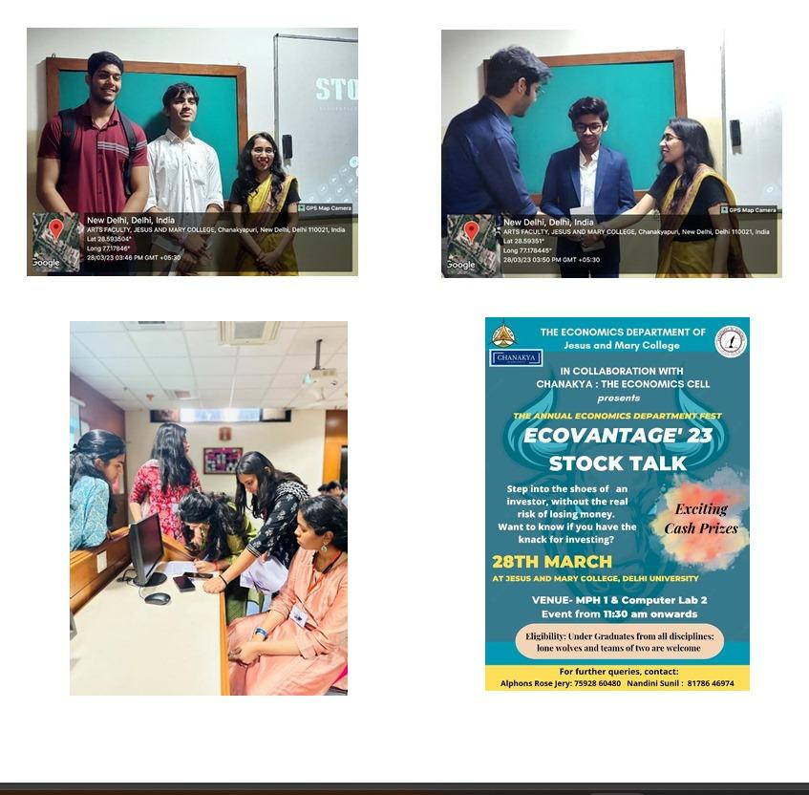

Group Discussion: Econovation- Battle of wits under point of rendezvous
Date: April 10, 2023
Time: 7:15-8:15 p.m.
Platform: Google Meet
Total Attendees: 52
Group discussions encourage an exchange of ideas and viewpoints and promote critical thinking. In order to enhance the communication and the problem solving skills of the students, Chanakya, the Economics Cell of Jesus and Mary College organised a group discussion covering topics like ‘Population: Boon or Bane’ and ‘4-Day Workweek’. Discussion on these topics enabled students to form a well-rounded opinion on some of the major macroeconomic problems prevalent in today’s day and age. To set the ball rolling, Sur Gupta and Srishti Beniwal made the participants aware of the topics and the rules for the group discussion. Faculty member, Ms. Ruchi Bhalla shared her insights on the first topic ‘Population: Boon or Bane’ and set the floor open for the participants. The discussion was initially inclined towards population being a bane as the growing population puts tremendous pressure on India’s limited resources and leads to widespread poverty, malnutrition, unemployment etc. An interesting fact brought into light by one of the participants was that almost 80% of the population in India (among the job seekers) is unemployable so the country should focus on the skill development of its human resources. The increasing population has also led to a brain drain in the country. The growing population can be considered a boon as an increase in the workforce leads to an increase in the output. Since about a third of the Indian population is under 35 so the youth can actively contribute to the growth and development of the nation, leading to a boost in the GDP. India can make its large population a boon by deploying skills and providing education, introducing programmes for family planning and generating awareness regarding the same among the underprivileged communities and by ensuring equitable distribution of resources. Attempts should be made to remove social stigma around sex and open conversations regarding contraceptives should be promoted. The participants also discussed China’s onechild policy and how it has adversely affected the sex ratio in the country. The next topic for discussion, ‘4-Day Workweek’, was introduced by Srishti Beniwal. Its potential benefits and drawbacks were discussed. The participants also discussed the potential impact of a 4-Day workweek on employer productivity, job satisfaction and the overall economy. The probable challenges of implementing a 4-Day workweek in different industries were also brought forward. The topic was discussed from an employee’s as well as a company’s perspective. Adopting this regime would lead to an increase in productivity, improved work-life balance and mental and emotional well-being and a significant drop in the running and commute costs. At the same time, some participants were of the opinion that a 4-day workweek would demand people to work for longer hours leading to more stress and less focus. It would increase their workload and might adversely affect their mental health. It was suggested that reducing the number of regular working hours would be more beneficial than implementing a 4-day workweek. This group discussion enabled the participants to explore different perspectives and present their thoughts and ideas in an articulate manner. All the attendees were encouraged to speak as the team decided that the best speaker would be given a special mention on Chanakya’s official Instagram page. The session ended with a vote of thanks delivered by the President, Nandini Sunil. The members as well as the meeting attendees showed active participation and made this group discussion interactive and insightful. They went back with fresh thoughts to ponder upon and a broadened perspective on the two topics discussed.
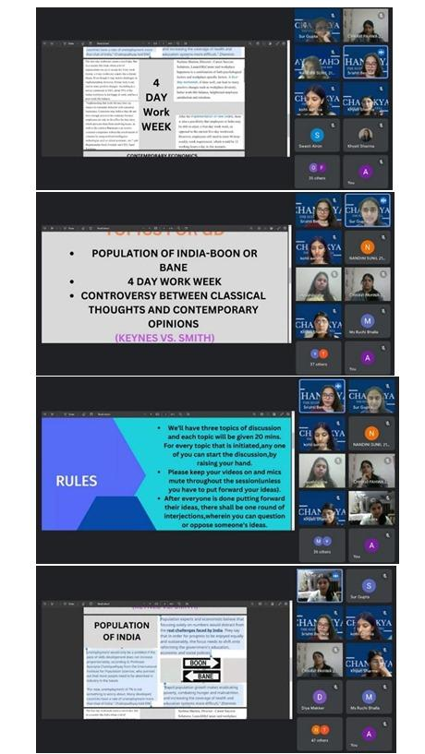

CRACK THE CASE- ACING CASE INTERVIEWS IN COLLABORATION
WITH BRIDGES FOR ENTERPRISE SSCBS
Date: June 15, 2023
Time: 7 pm onwards
Platform: Google Meet
Learning case interviews is of significant importance for individuals pursuing careers in consulting, strategy, and problem-solving-oriented fields. Case interviews are a common evaluation method used by top consulting firms and other organizations to assess candidates' analytical, critical thinking, and communication skills. Mastering case interviews can greatly enhance one's chances of securing coveted job opportunities and succeeding in these competitive industries. In light of the significance of the case interview, Chanakya collaborated with Shaheed Sukhdev College of Commerce to conduct a session enlightening students of JMC on Crack the Case- Acing Case Interviews through their newly launched casebook. The session will be based upon learning - What is consulting, the Pros, and cons of consulting, Success stories of consulting from Jesus and Mary College, what is a case interview and where it is used, Types of case interviews, the Gist of a profitability case and guesstimate. Additionally- How to do case interview preparation. It’ll be an enlighting session for all the students and extremely helpful for future interviews.

